***Работа с готовыми библиотеками***

Функции, возвращающие истину или ложь, называются *предикатом.*

Lodash – библиотека с доп.функциями.

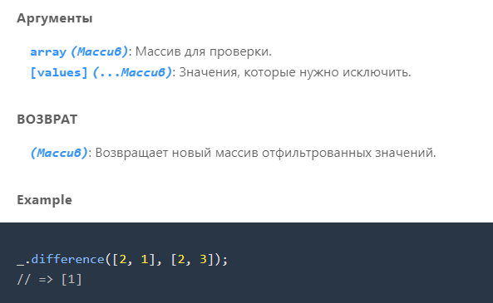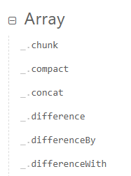Примеры функций lodash’а

Пример функций библиотеки lodash i

***Работа с функциями***

console.log(_.difference([1,2,3], [1,2]));

*// [1,2] - значения, которые нужно исключить*

console.log(_.difference([{ 'x': 2 }, { 'x': 1 }], [{ 'x': 1 }]));

*// { 'x': 1 } - значение, которое нужно исключить*

console.log(_.differenceBy([{ 'x': 2 }, { 'x': 1 }], [{ 'x': 1 }], 'x'));

*// => [{ 'x': 2 }]*

_.differenceBy([2.1, 1.2], [2.3, 3.4], Math.floor);

*// => [1.2]*

**const** arr = [10, 1, 21, 1, 33, 3, 33, 5, 8, 8, 1, 3, 5];

**const** sortedArr = _.uniq(arr);

sortedArr.sort(mySortFunc);

console.log(sortedArr);

**function** mySortFunc(a, b) {

    if (a>b)

        return 1

    else if (a == b)

        return 0

    else

        return -1

}

**const** userSkills = {

  css: 'b2',

  html: 'c1',

  js: 'a2',

  ts: null,

  react: undefined,

  vue: null,

  lodash: 'a1'

}

**const** userApprovedSkills = _.pickBy(userSkills, _.isString);

console.log(userApprovedSkills);

Скрипт для подключения библиотеки lodash

*<script src="https://cdn.jsdelivr.net/npm/lodash@4.17.21/lodash.min.js"></script>*

Скрипт для подключения библиотеки moveTo

<script src="https://cdnjs.cloudflare.com/ajax/libs/moveTo/1.8.2/moveTo.min.js"></script>

MoveTo

**const** moveto = new MoveTo();

**const** buttons = document.querySelectorAll('button');

buttons.forEach(btn **=>** moveto.registerTrigger(btn));

*//Регистрируем триггер на каждой кнопке*

**const** a = document.querySelector('a').addEventListener('click', fn)

**function** fn(event) {

    event.preventDefault();

**const** go = document.querySelector(event.target.getAttribute('href'));

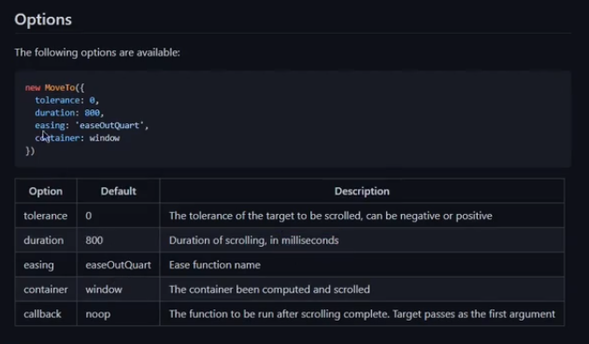    moveto.move(go, {

        duration: 1000

    });

}

**Другие возможности -> (параметры) MoveTo**

<!DOCTYPE html>

<html lang="en">

<head>

    <meta charset="">

    <meta http-equiv="X-UA-Compatible" content="IE=edge">

*<!-- указание режима совместимости для Internet Explorer -->*

    <meta name="viewport" content="width=device-width, initial-scale=1.0">

*<!-- определение параметров просмотра страницы на устройствах с*

*различными размерами экранов -->*

    <link rel="stylesheet" type="text/css" href="main.css">

    <title>Shop</title>

    <style>

        h1, h2 {

            color: cadetblue;

            text-align: center;

            border: 5px solid slateblue;

            border-radius: 10px;

            background-color:moccasin;

            margin-top: 0;

        }

        body {

            margin: 0;

            padding: 0;

            box-sizing: border-box;

            background-color:powderblue;

        }

        section {

            height: 100vh;

            width: 100%;

            background-color: azure;

        }

        header {

            background-color: antiquewhite;

            height: 100vh;

            width: 100%;

        }

        a {

            margin-top: 70px;

            text-align: center;

            display: block;

            color: coral;

            font-size: 24px;

        }

        p{

            color: steelblue;

            font-size: 22px;

            line-height: 30px;

            font-family: 'Franklin Gothic Medium', 'Arial Narrow', Arial, sans-serif;

        }

    </style>

</head>

<body>

    <header id="top">

        <h1> Hello World </h1>

        <div class="actions">

            <button data-target="#contacts" data-mt-duration="2000"> Contacts </button>

            <button data-target="#features"data-mt-duration="1200"> Our information </button>

            <a href="#contacts"> this link for bottom teleportation </a>

        </div>

    </header>

    <section id="features">

        <h2> Features </h2>

        <p>

            1. Technological expertise: The factory has highly qualified personnel and advanced equipment to produce high-quality rebar products.

            <br><br>

            2. Innovative processes: Modern technologies and innovative methods are used in production, which makes it possible to create reinforcement structures with unique properties and durability.

            <br><br>

            3. Flexibility and individual approach: The factory is able to offer customers customized solutions and specialized products according to their needs and requirements.

            <br><br>

            4. Quality control: Quality control processes at each stage of production guarantee the reliability and safety of rebar products, compliance with standards and requirements.

            <br><br>

            5. Sustainability and environmental responsibility: The factory pays attention to the environmental aspects of production and is focused on the sustainability of its products.

        </p>

    </section>

    <section id="contacts">

        <div>

            <h2> Contacts </h2>

            <button data-target="#top" data-mt-duration="2000"> Go up! </button>

        </div>

    </section>

    <script src="https://cdnjs.cloudflare.com/ajax/libs/moveTo/1.8.2/moveTo.min.js"></script>

    <script src="app.js"></script>

</body>

</html>

***ToolTip***

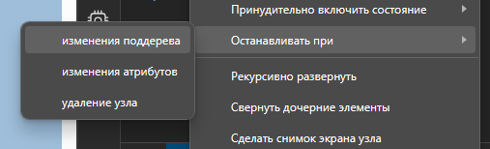Для понимания работы анимаций, эффектов итп. можно останавливать программу в определённый момент. ->

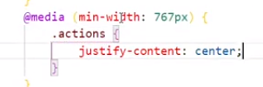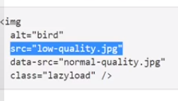***OverlayScrollbars – библиотека***

***LazyLoad – поэтапная загрузка страницы***

class="lazyload" data-src="robert.brindley.jpg"

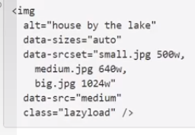Подбор картинки под ширину экрана (низкое, среднее, хорошее качесвто).

loading="lazy" – по умолчанию встроен в карту.

******data-expand=”-110” – даёт возможность загружать картинку не сразу, а по истечении времени.

*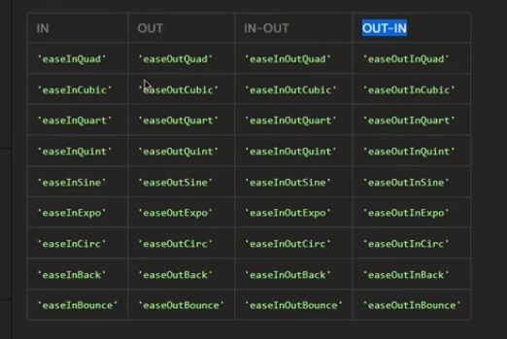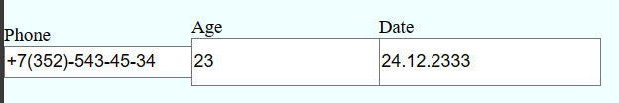Возможность ограничения inputs числовыми значениями*

**const** moveto = new MoveTo();

**const** buttons = document.querySelectorAll('button');

buttons.forEach(btn **=>** moveto.registerTrigger(btn));

*//Регистрируем триггер на каждой кнопке*

**const** a = document.querySelector('a').addEventListener('click', fn)

**function** fn(event) {

    event.preventDefault();

**const** go = document.querySelector(event.target.getAttribute('href'));

    console.log(event.target.getAttribute('href'));

    console.log('hello');

    moveto.move(go, {

        duration: 1000

    });

}

tippy('[data-tippy-content]',{

    theme: 'light'

});

OverlayScrollbars(document.querySelectorAll('.actions'), {

    scrollbars: {

        autoHide: 'scroll'

    }

});

OverlayScrollbars(document.querySelectorAll('.block'), {

    scrollbars: {

        autoHide: 'scroll'

    }

});

**const** swiper = new Swiper('.swiper', {

*// Optional parameters*

    direction: 'horizontal',

    loop: true,

    slidesPerView: 3,

    spaceBetween: 20,

    centeredSlides: true,

    centeredSlidesBounds: true,

*// If we need pagination*

    pagination: {

      el: '.swiper-pagination',

    },

*// Navigation arrows*

    navigation: {

      nextEl: '.swiper-button-next',

      prevEl: '.swiper-button-prev',

    },

*// And if we need scrollbar*

*// scrollbar: {*

*//   el: '.swiper-scrollbar',*

*// },*

  });

IMask(document.getElementById('phone'), {

    mask: '+{7}(000)-000-00-00',

});

IMask(document.getElementById('age'), {

    mask: Number,

    min: 0,

    max: 121,

});

IMask(

    document.getElementById('date'),

    {

      mask: Date,

      autofix: true,

      blocks: {

        d: {mask: IMask.MaskedRange, placeholderChar: 'd', from: 1, to: 31, maxLength: 2},

        m: {mask: IMask.MaskedRange, placeholderChar: 'm', from: 1, to: 12, maxLength: 2},

        Y: {mask: IMask.MaskedRange, placeholderChar: 'y', from: 1900, to: 2999, maxLength: 4}

      }

    }

  )

**const** tog = document.querySelector('span');

**const** form = document.querySelector('form');

tog.addEventListener('click', handleToggle);

**function** handleToggle() {

  if(form.style.opacity == 0){

    anime({

      targets: form,

      opacity: 1,

      height: form.scrollHeight,

      duration: 2500,

      easing: 'easeInOutQuad',

    });

  } else {

    anime({

      targets: form,

      opacity: 0,

      height: 0,

      duration: 2500,

      easing: 'easeInOutQuad',

    });

  }

}

<!DOCTYPE html>

<html lang="en">

<head>

    <meta charset="">

    <meta http-equiv="X-UA-Compatible" content="IE=edge">

*<!-- указание режима совместимости для Internet Explorer -->*

    <meta name="viewport" content="width=device-width, initial-scale=1.0">

*<!-- определение параметров просмотра страницы на устройствах с*

*различными размерами экранов -->*

    <link rel="stylesheet" type="text/css" href="main.css">

    <link rel="stylesheet" href="https://unpkg.com/tippy.js@6/themes/light.css"/>

    <link rel="stylesheet" href="https://cdnjs.cloudflare.com/ajax/libs/overlayscrollbars/1.13.1/css/OverlayScrollbars.min.css" integrity="sha512-jN4O0AUkRmE6Jwc8la2I5iBmS+tCDcfUd1eq8nrZIBnDKTmCp5YxxNN1/aetnAH32qT+dDbk1aGhhoaw5cJNlw==" crossorigin="anonymous" referrerpolicy="no-referrer" />

    <link rel="stylesheet" href="https://cdn.jsdelivr.net/npm/swiper@11/swiper-bundle.min.css"/>

    <title>Shop</title>

    <style>

        h1, h2 {

            color: cadetblue;

            text-align: center;

            border: 5px solid slateblue;

            border-radius: 10px;

            background-color:moccasin;

            margin-top: 0;

        }

        .tippy-box[data-theme~=light] {

            color: cornflowerblue;

        }

        .actions > * {

            flex-shrink: 0;

        }

        .block > * {

*/* flex-shrink: 0; */*

        }

        .overlay {

            width: 100%;

            overflow: hidden;

        }

        .block button {

            width: 90px;

*/* margin: 2%; */*

            margin-top: 5%;

        }

        .swiper-slide-prev{

*/* margin-right: 10px; */*

        }

        .block {

            display: flex;

        }

*/* .os-content {*

*display: flex;*

*} */*

        .swiper-slide{

            height: 100px;

            color: gray;

            background-color:lavender;

            border: 10px solid slategrey;

            border-radius: 10px;

            width: 150px;

            font-size: 28px;

            font-family: 'Trebuchet MS', 'Lucida Sans Unicode', 'Lucida Grande', 'Lucida Sans', Arial, sans-serif;

        }

        form {

*/* display: flex; */*

            flex-direction: column;

            gap: 1rem;

            padding: 1rem;

            border: 3px solid blue;

            margin: 5%;

        }

    </style>

</head>

<body>

    <header id="top">

        <h1> Hello World </h1>

        <div class="overlay">

            <div class="actions">

                <button data-target="#contacts"

                data-mt-duration="2000" data-tippy-content="You can contact us!">

                    Contacts

                </button>

                <button data-target="#features"data-mt-duration="1200"> Our information </button>

                <a href="#contacts"> this link for bottom teleportation </a>

            </div>

        </div>

    </header>

    <section id="features" style="flex-direction: column;">

        <h2> Features </h2>

        <span> Toggle ._. </span>

        <div class="swiper">

*<!-- Additional required wrapper -->*

            <div class="swiper-wrapper">

*<!-- Slides -->*

              <div class="swiper-slide">Slide 1</div>

              <div class="swiper-slide">Slide 2</div>

              <div class="swiper-slide">Slide 3</div>

              <div class="swiper-slide">Slide 4</div>

              <div class="swiper-slide">Slide 5</div>

              ...

            </div>

*<!-- If we need pagination -->*

            <div class="swiper-pagination"></div>

*<!-- If we need navigation buttons -->*

            <div class="swiper-button-prev"></div>

            <div class="swiper-button-next"></div>

*<!-- If we need scrollbar -->*

*<!-- <div class="swiper-scrollbar"></div> -->*

          </div>

          <form autocomplete="off" style="opacity: 0; overflow: hidden; height: 0;">

            <label>

                Phone

                <input type="text" id="phone">

            </label>

            <label>

                Age

                <input type="text" id="age">

            </label>

            <label>

                Date

                <input type="text" id="date">

            </label>

          </form>

*<!-- <p>*

*1. Technological expertise: The factory has highly qualified personnel and advanced equipment to produce high-quality rebar products.*

*<br><br>*

*2. Innovative processes: Modern technologies and innovative methods are used in production, which makes it possible to create reinforcement structures with unique properties and durability.*

*<br><br>*

*3. Flexibility and individual approach: The factory is able to offer customers customized solutions and specialized products according to their needs and requirements.*

*<br><br>*

*4. Quality control: Quality control processes at each stage of production guarantee the reliability and safety of rebar products, compliance with standards and requirements.*

*<br><br>*

*5. Sustainability and environmental responsibility: The factory pays attention to the environmental aspects of production and is focused on the sustainability of its products.*

*</p> -->*

    </section>

    <section id="contacts">

        <div>

            <h2> Contacts </h2>

            <button data-target="#top" data-mt-duration="2000"> Go up! </button>

        </div>

        <div class="overlay">

            <div class = "block">

                <button> Some 1</button>

                <button> Some 2</button>

                <button> Some 3</button>

                <button> Some 4</button>

            </div>

        </div>

    </section>

    <iframe src="https://www.google.com/maps/embed?pb=!1m18!1m12!1m3!1d13209.668630923234!2d-118.32521217429408!3d34.13566810571829!2m3!1f0!2f0!3f0!3m2!1i1024!2i768!4f13.1!3m3!1m2!1s0x80c2bf0a45505a7d%3A0xabb7acc626709843!2z0JfQvdCw0Log0JPQvtC70LvQuNCy0YPQtNCw!5e0!3m2!1sru!2sru!4v1706022412509!5m2!1sru!2sru" width="900" height="750" style="border:0;" allowfullscreen="" class="lazyload" referrerpolicy="no-referrer-when-downgrade"></iframe>

    <section class="images">

        <img class="lazyload" data-src="landscape.jpg">

        <img class="lazyload" data-src="d.oleyn.jpg">

        <img class="lazyload" data-src="robert.brindley.jpg">

    </section>

    <script src="https://unpkg.com/@popperjs/core@2"></script>

    <script src="https://unpkg.com/tippy.js@6"></script>

    <script src="https://cdnjs.cloudflare.com/ajax/libs/moveTo/1.8.2/moveTo.min.js"></script>

    <script src="https://cdnjs.cloudflare.com/ajax/libs/overlayscrollbars/1.13.1/js/OverlayScrollbars.min.js" integrity="sha512-B1xv1CqZlvaOobTbSiJWbRO2iM0iii3wQ/LWnXWJJxKfvIRRJa910sVmyZeOrvI854sLDsFCuFHh4urASj+qgw==" crossorigin="anonymous" referrerpolicy="no-referrer"></script>

    <script src="https://cdn.jsdelivr.net/npm/swiper@11/swiper-bundle.min.js"></script>

    <script src="https://unpkg.com/imask"></script>

    <script src="http://afarkas.github.io/lazysizes/lazysizes.min.js"></script>

    <script src="https://cdnjs.cloudflare.com/ajax/libs/animejs/3.2.2/anime.min.js" integrity="sha512-aNMyYYxdIxIaot0Y1/PLuEu3eipGCmsEUBrUq+7aVyPGMFH8z0eTP0tkqAvv34fzN6z+201d3T8HPb1svWSKHQ==" crossorigin="anonymous" referrerpolicy="no-referrer"></script>

    <script src="app.js"></script>

</body>

</html>

@import url('https://fonts.googleapis.com/css2?family=Kalam:wght@300&family=Merriweather:ital,wght@1,300&display=swap');

*/* The Modal (background) */*

.modal {

  display: none; */* Hidden by default */*

  position: fixed; */* Stay in place */*

  z-index: 1; */* Sit on top */*

  left: 0;

  top: 0;

  width: 100%; */* Full width */*

  height: 100%; */* Full height */*

  overflow: auto; */* Enable scroll if needed */*

  background-color: rgb(0,0,0); */* Fallback color */*

  background-color: rgba(0,0,0,0.4); */* Black w/ opacity */*

}

*/* Modal Content/Box */*

.modal-content {

  background-color: cornflowerblue;

  border-radius: 10px;

  font-size: 20px;

*/* border: 10px solid yellow; */*

  color: aliceblue;

  margin: 15% auto; */* 15% from the top and centered */*

  padding: 20px;

  border: 1px solid #888;

  width: 80%; */* Could be more or less, depending on screen size */*

}

*/* The Close Button */*

.close {

  color: #aaa;

  float: right;

  font-size: 28px;

  font-weight: bold;

}

.open {

  display: block;

}

button {

  margin: 0 auto;

  display: block;

  margin-top: 10%;

  height: 5rem;

  width: 20rem;

  font-size: 30px;

  background-color: rosybrown;

  color: beige;

  font-weight: 600;

  font-family: 'Merriweather', serif;

  border-radius: 10px;

  border-width: 4px;

  border-color: wheat

}

.close:hover,

.close:focus {

  color: black;

  text-decoration: none;

  cursor: pointer;

}

body {

  margin: 0;

  padding: 0;

  box-sizing: border-box;

  background-color:powderblue;

}

section {

  height: 100vh;

  width: 100%;

  background-color: azure;

}

header {

  background-color: antiquewhite;

  height: 100vh;

  width: 100%;

}

a {

  margin-top: 70px;

  text-align: center;

  display: block;

  color: coral;

  font-size: 24px;

}

p{

  color: steelblue;

  font-size: 22px;

  line-height: 30px;

  font-family: 'Franklin Gothic Medium', 'Arial Narrow', Arial, sans-serif;

}

img {

  display: block;

  width: 550px;

  margin: auto;

  border-radius: 20px;

  margin-top: 4%;

  margin-bottom: 2%;

}

iframe {

  display: block;

  margin: auto;

  border-radius: 20px;

}

form {

  margin-top: 20%;

  height: 500px;

  font-size: 25px;

}

label {

  display: inline-block;

  width: 150px;

  height: 400px;

  margin-right: 10%;

}

input#phone {

  height: 10%;

}

input#age {

  height: 15%;

}

input#date {

  height: 15%;

}

input[type="text"]

{

  font-size:24px;

}

span {

  color:darkslateblue;

  font-size: 30px;

}